**STORE PROCEDURE**

**CREATE TABLE**

**create table STUDENTS (stdID int primary key , stdName varchar(255), stdClass varchar(255),stdMobile varchar(255))**

**SELECT TABLE**

**Select *from STUDENTS**

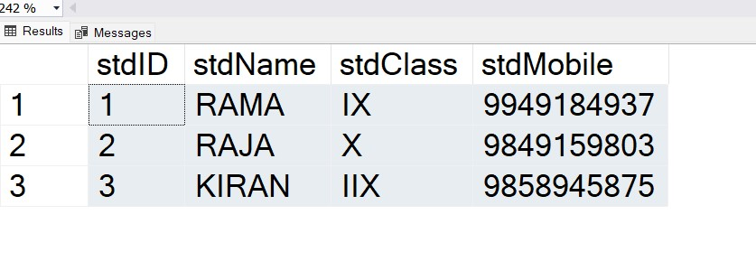

**CREATING PROCUDURE WITHOUT PARRAMETERS**

**create procedure selectStudents**

**AS**

**Select *from Students**

**GO**

**exec selectStudents**

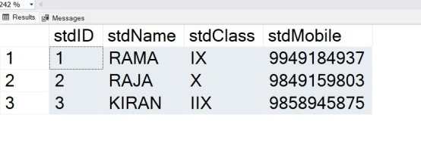**OUTPUT**

**CREATING PROCUDURE WITH PARRAMETERS**

create procedure selectwithClass @stdClass varchar(255)

as

select *from Students Where stdClass= @stdClass

go

exec selectwithClass @stdClass = 'IX'

**INSERTING VALUES INTO PROCUDURE**

create procedure insertStudents

@stdID int ,

@stdName varchar(255) ,

@stdClass varchar(255) ,

@stdMobile varchar(255)

as

insert into Students values(@stdID,@stdName ,@stdClass ,@stdMobile)

go

**exec insertStudents @stdID=4 , @stdName='Krish' ,@stdClass='V' ,@stdMobile='900626548'**

**UPDATING VALUES INTO PROCUDURE**

create procedure updateStudent @stdID int , @stdName varchar(255)

as

update students set stdName=@stdName where stdID =@stdID

go

**exec updateStudent @stdID=1 ,@stdName ='RAMA KRISHNA'**

**DELETING VALUES INTO PROCUDURE**

create procedure deleteStudent @stdID int

as

delete from Students Where stdID = @stdID

go

**exec deleteStudent @stdID=4**

**SINGLE PROCEDURE SYNTAX**

create procedure crudstudents

@stdID int = null,

@stdName varchar(255) = null,

@stdClass varchar(255) = null,

@stdMobile varchar(255) = null,

@Action varchar(255) =''

AS

**BEGIN**

IF @Action = 'select'

BEGIN

select *from Students

END

ELSE IF @Action='insert'

BEGIN

insert into STUDENTS values(@stdID ,@stdName ,@stdClass ,@stdMobile)

END

ELSE IF @Action='update'

BEGIN

update STUDENTS set stdName = @stdName where stdID = @stdID

END

ELSE IF @Action='Delete'

BEGIN

Delete STUDENTS Where stdID=@stdID

END

END

**EXEC crudstudents @stdID=1 , @Action = 'Delete'**

**EXEC crudstudents @stdID=1 , @stdName ='RAMA KRISHNA' , @stdClass ='X' , @stdMobile ='9845687589' ,@Action ='insert'**

**EXEC crudstudents @Action ='select'**